„I still can´t believe that I´m actually living my dream now!”

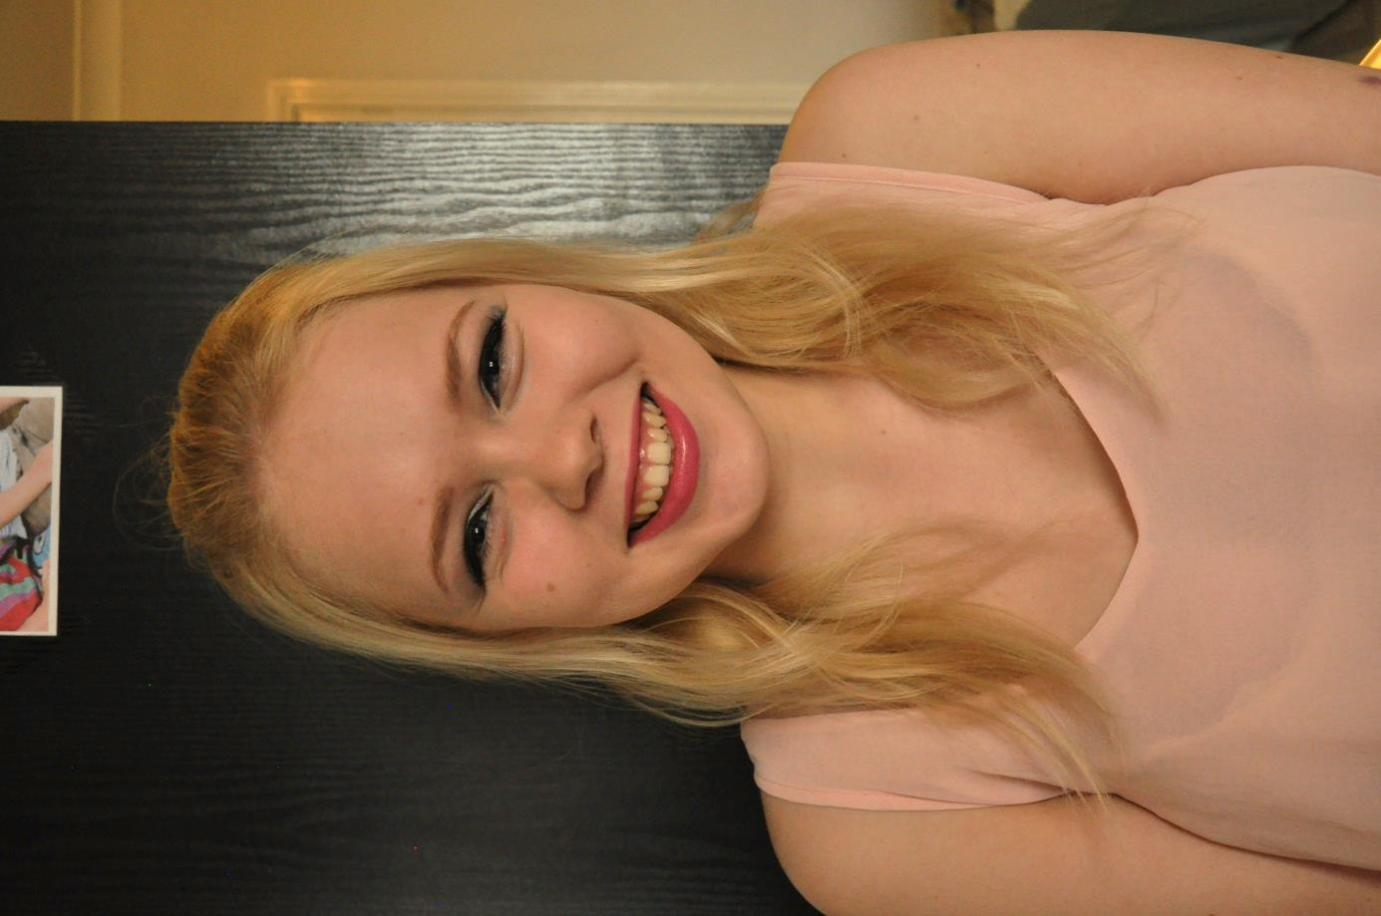

Gemma

**Photographs** Lena Gläser

eee

“

I still can´t believe that I´m actually living my dream now!”

*We all can´t get enough of her, since she brought out her first album two years ago. Overnight she became one of the* ***most successful newcomers of 2013.*** *Since then nobody can reach her and not just teenagers are in love with her voice – everyone seems transfixed with her! Some people already call her the* ***“New Beyonce.”***

L

“It´s hard, but I love my job. I love to entertain people and to show them my passion. **This is what I always wanted to *do.”***

*So you found your dream job?*

“Definitely! Sure there are negative sites, for example that you can´t see your family and friends so often and that part of your private life disappears. And all the stress – I sleep 4-5 hours a day. But it´s how you deal with it. And at the moment **I couldn´t imagine doing anything else!”**

*Would you have ever thought that you could have such a success in such a short time?*

“No. Never. I was already planning to go to Uni to study music and drama but then **my life turned 180 .** I still can´t believe that I´m living my dream now!” *Lena Gläser*

ooking good as always, we had an exclusive interview with

Gemma in London. Even though it´s half past seven, we don´t notice any kind of tiredness or stress. She is just cheerful and happy as we all know her. “I do lots of sport and yoga to keep me fit for the stage. And I´m trying to eat healthily and balanced.”

“That´s one of my recipes for my success. Otherwise I couldn´t cope with all the stress and jetlag.”

*What else do you do to stay healthy?*

“Mental training combined with sport and a healthy life style as I said. I try to think positive, I mean what is the worse that could happen? l I always look ahead and try not to worry too much. Happiness and success is a choice. Your choice. **My only goal in life right now is to be happy!”**

*How hard is life as a really successful newcomer for you?*

16

POPULAR February 2015 *Subscribe at www.popularmagazine.com*